# Practical 1

Study of Android Development Toolkit

What is Android?

Android is an open source and Linux-based Operating System for mobile devices such as smartphones and tablet computers. Android was developed by the Open Handset Alliance, led by Google, and other companies.

Android offers a unified approach to application development for mobile devices which means developers need to develop only for Android, and their applications should be able to run on different devices powered by Android.

The first beta version of the Android Software Development Kit (SDK) was released by Google in 2007, whereas the first commercial version, Android 1.0, was released in September 2008.

You can start your Android application development on either of the following operating systems:

o Microsoft Windows XP or later version.

o Mac OS X 10.5.8 or later version with Intel chip.

o Linux including GNU C Library 2.7 or later.

Second point is that all the required tools to develop Android applications are freely available and can be downloaded from the Web. Following is the list of software's you will need before you start your Android application programming.

o Java JDK5 or JDK6 or higher version

o Android SDK

o Eclipse IDE for Java Developers (optional)

o Android Development Tools (ADT) Eclipse Plugin (optional)

Here last two components are optional and if you are working on Windows machine then these components make your life easy while doing Java based application development.

Steps for Setting up the Environment for Android Development Toolkit:

Setup Java Development Kit (JDK)

Setup Android SDK

You can download the latest version of Android SDK from Android’s official website: http://developer.android.com/sdk/index.html. If you are installing SDK on Windows machine, then you will find ainstaller_rXX-windows.exe, so just download and run this exe which will launch Android SDK Tool Setup wizard to guide you throughout the installation, so just follow the instructions carefully. Finally, you will have Android SDK Tools installed on your machine.

Setup Eclipse IDE

To install Eclipse IDE, download the latest Eclipse binaries from http://www.eclipse.org/downloads/. Once you have downloaded the installation, unpack the binary distribution into a convenient location. For example, in C:\eclipse on windows, or /usr/local/eclipse on Linux and finally set PATH variable appropriately.

Setup Android Development Tools (ADT) Plugin

This step will help you in setting Android Development Tool plugin for Eclipse.

Create Android Virtual Device

To test your Android applications, you will need a virtual Android device. So before we start writing our code, let us create an Android virtual device. Launch Android AVD Manager using Eclipse menu options Window > AVD Manager> which will launch Android AVD Manager. Use New button to create a new Android Virtual Device and enter the following information, before clicking Create AVD button.

If your AVD is created successfully it means your environment is ready for Android application development. If you like, you can close this window using top-right cross button. Better you re-start your machine and once you are done with this last step, you are ready to proceed for your first Android example

# Practical 2

Develop an android app which displays “Hello, welcome to Android Lab” message.

activitymain.xml:

<?xml version="1.0" encoding="utf-8"?>

<android.support.constraint.ConstraintLayout

xmlns:android="http://schemas.android.com/apk/res/android"

xmlns:tools="http://schemas.android.com/tools"

xmlns:app="http://schemas.android.com/apk/res-auto"

android:layout_width="match_parent"

android:layout_height="match_parent"

tools:context="com.example.helloworld.MainActivity">

<TextView

android:layout_width="wrap_content"

android:layout_height="wrap_content"

android:text="Hello, Welcome to Android Lab"

app:layout_constraintBottom_toBottomOf="parent"

app:layout_constraintLeft_toLeftOf="parent"

app:layout_constraintRight_toRightOf="parent"

app:layout_constraintTop_toTopOf="parent" />

</android.support.constraint.ConstraintLayout>

MainActivity.java:

package com.example.helloworld;

import android.support.v7.app.AppCompatActivity;

import android.os.Bundle;

public class MainActivity extends AppCompatActivity {

@Override

protected void onCreate(Bundle savedInstanceState) {

super.onCreate(savedInstanceState);

setContentView(R.layout.activity_main);

}

}

# Output:

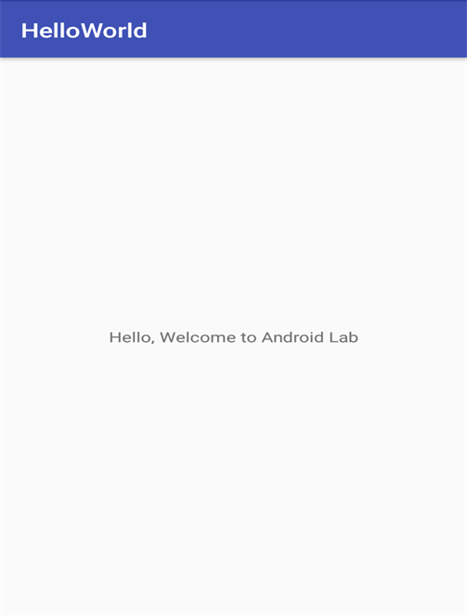

# Practical 3

Study about various Android Layouts.

# Android Layouts and Types of Android Layouts

Android Layouts:

A Layout dictates the alignment of widgets (such as Text, Buttons, EditText box) as we see in the Android Application. All the visual structure we see in an android app is designed in a Layout. Every Layout is defined in an xml file which is located in App > res > Layout in New Android Studio.

In this we are going to discuss briefly on Types of Layouts as they are going to be needed in every Android Application Project we create.

Types of Layouts:

The layouts most commonly used are:

1. Linear Layout

2. Relative Layout

However, there are several other layouts such as:

1. Web View Layout

2. Frame Layout

3. List View Layout

4. Grid View Layout

Here we try to discuss these layouts in brief as these layouts are used extensively in any Android Project.

Linear Layout:

Linear Layout is a layout which aligns the widgets or elements in a linear (Straight) fashion. Linear Layout consists of two types of orientation:

1. Vertical Orientation,

2. Horizontal Orientation.

Vertical Orientation is shown above where the widgets such as Text View, Edit Text, and Button are aligned in a Vertical manner.

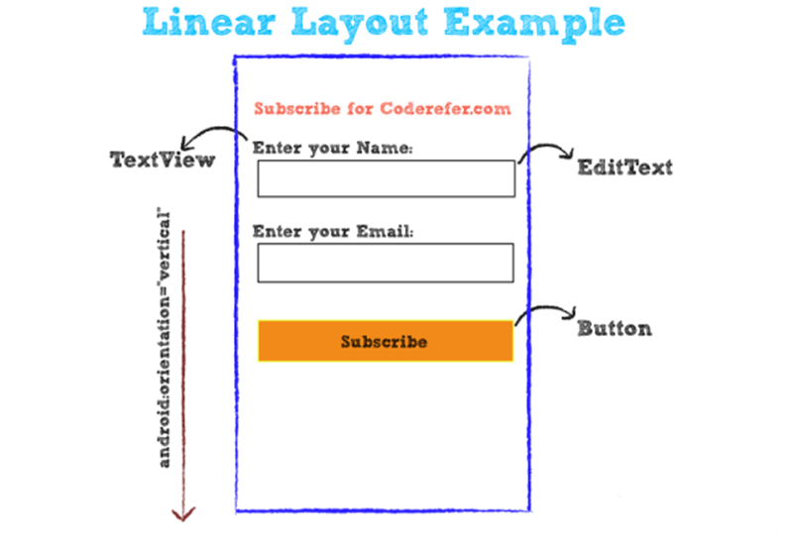

Similarly, there exists a Horizontal Orientation where the widgets are arranged in a horizontal manner. Horizontal orientation or Vertical orientation will be discussed further in our next articles.

Relative Layout:

Relative Layout is a layout where the widgets (such as Text Views, Buttons, etc.) are represented with respect to previous widget or parent View. A Relative Layout example is shown in the figure below.

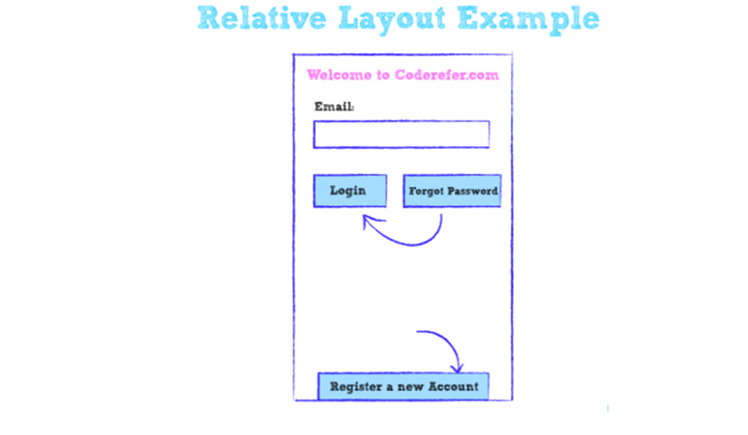

Here in the above figure, ‘Forgot Password’ button is positioned relative to ‘Login’ Button, whereas ‘Register a new Account’ is aligned with respect to Parent Layout.

List View:

A List View is a View Layout where all the items are specified in the form of a list as shown in fig. below.

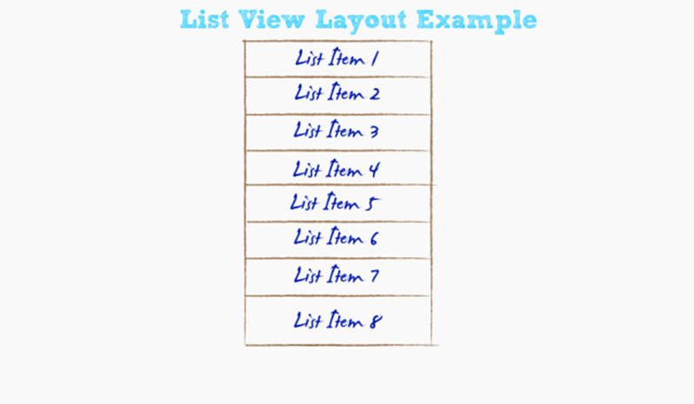

It is one of the very useful form of layouts. List view, as shown in figure below consists of an order of List items as shown below.

List View will further be discussed in the future article along with an example.

Grid View:

A Grid View is a View Layout where the items (such as pictures, files etc.) are placed in a Grid manner as shown in figure below.

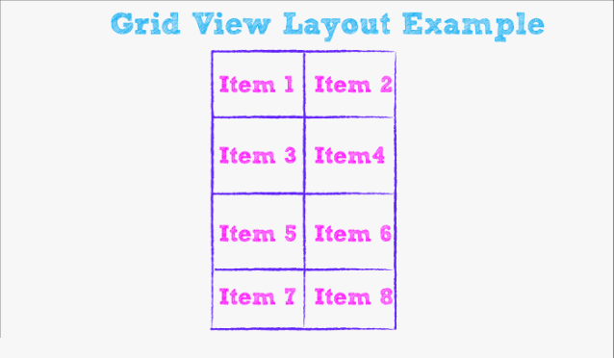

These are the brief discussions on typical Android Layouts which are mostly used in Android Development.

# Practical 4

Implement multiple text view in relative layout also include a web link in the text.

activity_main.xml:

<?xml version="1.0" encoding="utf-8"?>

<android.widget.RelativeLayout

xmlns:android="http://schemas.android.com/apk/res/android"

xmlns:app="http://schemas.android.com/apk/res-auto"

xmlns:tools="http://schemas.android.com/tools"

android:layout_width="match_parent"

android:layout_height="match_parent"

tools:context="com.example.estafador.prac5_shubham.MainActivity">

<TextView

android:id="@+id/textView3"

android:layout_width="wrap_content"

android:layout_height="wrap_content"

android:layout_alignParentLeft="true"

android:layout_alignParentStart="true"

android:layout_alignParentTop="true"

android:layout_marginLeft="20dp"

android:layout_marginStart="20dp"

android:layout_marginTop="18dp"

android:text="NEWSPAPERS"

android:textSize="30sp"

android:textStyle="bold" />

<TextView

android:id="@+id/textView4"

android:layout_width="wrap_content"

android:layout_height="wrap_content"

android:layout_marginTop="25dp"

android:text="English"

android:textSize="24sp"

android:textStyle="bold"

android:layout_below="@+id/textView3"

android:layout_alignLeft="@+id/textView3"

android:layout_alignStart="@+id/textView3" />

<TextView

android:id="@+id/textView5"

android:layout_width="wrap_content"

android:layout_height="wrap_content"

android:layout_marginTop="16dp"

android:text="@string/e1"

android:layout_below="@+id/textView4"

android:layout_alignLeft="@+id/textView4"

android:layout_alignStart="@+id/textView4" />

<TextView

android:id="@+id/textView6"

android:layout_width="wrap_content"

android:layout_height="wrap_content"

android:layout_marginTop="12dp"

android:text="@string/e2"

android:layout_below="@+id/textView5"

android:layout_alignLeft="@+id/textView5"

android:layout_alignStart="@+id/textView5" />

<TextView

android:id="@+id/textView7"

android:layout_width="wrap_content"

android:layout_height="wrap_content"

android:layout_alignLeft="@+id/textView6"

android:layout_alignStart="@+id/textView6"

android:layout_below="@+id/textView6"

android:layout_marginTop="37dp"

android:text="Hindi"

android:textSize="24sp"

android:textStyle="bold" />

<TextView

android:id="@+id/textView8"

android:layout_width="wrap_content"

android:layout_height="wrap_content"

android:layout_alignLeft="@+id/textView7"

android:layout_alignStart="@+id/textView7"

android:layout_below="@+id/textView7"

android:layout_marginTop="14dp"

android:text="@string/e3" />

<TextView

android:id="@+id/textView9"

android:layout_width="wrap_content"

android:layout_height="wrap_content"

android:layout_alignLeft="@+id/textView8"

android:layout_alignStart="@+id/textView8"

android:layout_below="@+id/textView8"

android:layout_marginTop="17dp"

android:text="@string/e4" />

<TextView

android:id="@+id/textView10"

android:layout_width="wrap_content"

android:layout_height="wrap_content"

android:layout_alignLeft="@+id/textView9"

android:layout_alignStart="@+id/textView9"

android:layout_below="@+id/textView9"

android:layout_marginTop="53dp"

android:text="Gujarati"

android:textSize="24sp"

android:textStyle="bold" />

<TextView

android:id="@+id/textView11"

android:layout_width="wrap_content"

android:layout_height="wrap_content"

android:layout_alignLeft="@+id/textView10"

android:layout_alignStart="@+id/textView10"

android:layout_below="@+id/textView10"

android:layout_marginTop="9dp"

android:text="@string/e5" />

<TextView

android:id="@+id/textView12"

android:layout_width="wrap_content"

android:layout_height="wrap_content"

android:layout_alignLeft="@+id/textView11"

android:layout_alignStart="@+id/textView11"

android:layout_below="@+id/textView11"

android:layout_marginTop="19dp"

android:text="@string/e6"/>

</android.widget.RelativeLayout>

Strings.xml

<resources>

<string name="app_name">rough</string>

<string name="e1"><a href="http://timesofindia.indiatimes.com/">Times of India</a></string>

<string name="e2"><a

href="http://economictimes.indiatimes.com/">Economic Times</a></string>

<string name="e3"><a href="https://www.bhaskar.com/">Dainik Bhaskar</a></string>

<string name="e4"><a

href="http://navbharattimes.indiatimes.com/">Navbharat Times</a></string>

<string name="e5"><a href="http://www.gujaratsamachar.com/">Gujarat Samachar</a></string>

<string name="e6"><a href="http://sandesh.com/">Sandesh</a></string> </resources>

MainActivity.java

package com.example.estafador.prac5_shubham;

import android.support.v7.app.AppCompatActivity; import android.os.Bundle;

import android.text.method.LinkMovementMethod; import android.widget.TextView;

public class MainActivity extends AppCompatActivity {

@Override

protected void onCreate(Bundle savedInstanceState) { super.onCreate(savedInstanceState); setContentView(R.layout.activity_main);

TextView t1 = (TextView) findViewById(R.id.textView5); t1.setMovementMethod(LinkMovementMethod.getInstance()); TextView t2 = (TextView) findViewById(R.id.textView6); t2.setMovementMethod(LinkMovementMethod.getInstance()); TextView t3 = (TextView) findViewById(R.id.textView8); t3.setMovementMethod(LinkMovementMethod.getInstance()); TextView t4 = (TextView) findViewById(R.id.textView9); t4.setMovementMethod(LinkMovementMethod.getInstance()); TextView t5 = (TextView) findViewById(R.id.textView11); t5.setMovementMethod(LinkMovementMethod.getInstance()); TextView t6 = (TextView) findViewById(R.id.textView12); t6.setMovementMethod(LinkMovementMethod.getInstance());

}

}

# Output:

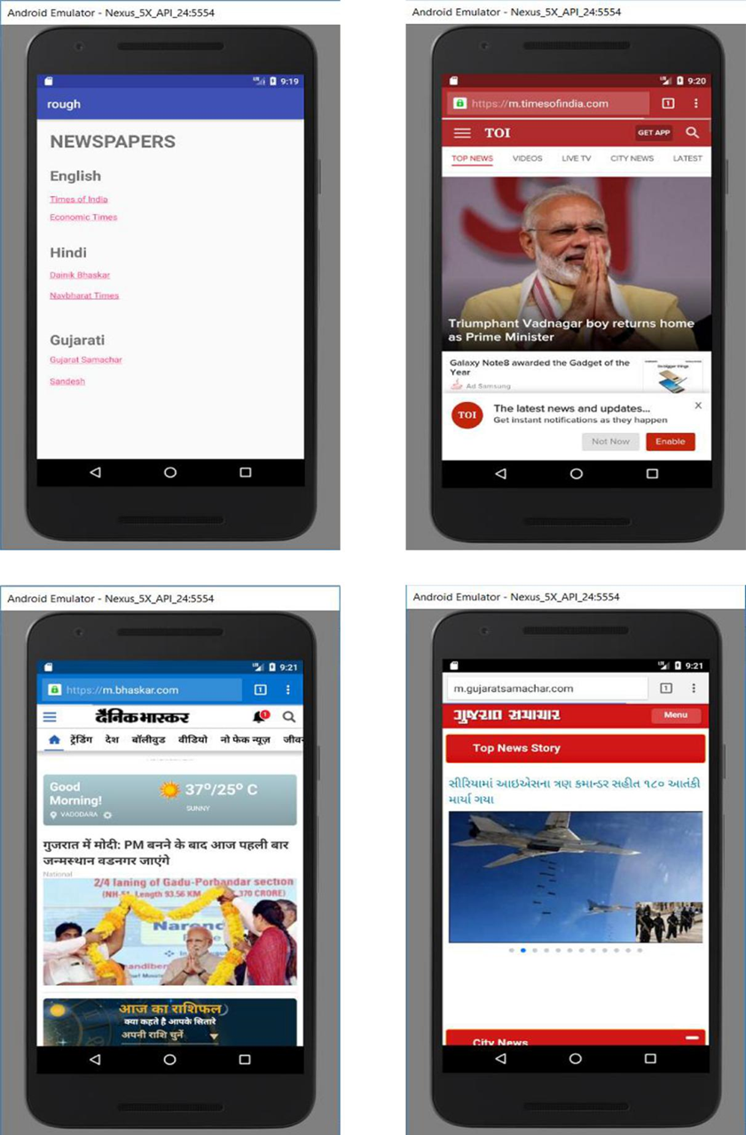

# Practical 5

Develop calculator Android Application

activitymain.xml:

<?xml version="1.0" encoding="utf-8"?>

<LinearLayout xmlns:android="http://schemas.android.com/apk/res/android"

xmlns:app="http://schemas.android.com/apk/res-auto"

xmlns:tools="http://schemas.android.com/tools"

android:layout_width="match_parent"

android:layout_height="match_parent"

android:orientation="vertical"

tools:context="com.example.calculator.MainActivity">

<TextView

android:layout_width="match_parent"

android:layout_height="wrap_content"

android:text="CALCULATOR"

android:gravity="center" />

<TextView

android:layout_width="match_parent"

android:layout_height="wrap_content"

android:text="Number 1"

android:layout_marginTop="20dp"/>

<EditText

android:layout_width="wrap_content"

android:layout_height="wrap_content"

android:hint="number 1"

android:id="@+id/num1"

android:layout_marginTop="20dp"

android:inputType="number"

/>

<TextView

android:layout_width="match_parent"

android:layout_height="wrap_content"

android:text="Number 2"

android:layout_marginTop="20dp"/>

<EditText

android:layout_width="wrap_content"

android:layout_height="wrap_content"

android:hint="number 2"

android:id="@+id/num2"

android:layout_marginTop="20dp"

android:inputType="number"/>

<Button

android:layout_width="wrap_content"

android:layout_height="wrap_content"

android:text="Add"

android:layout_marginTop="10dp"

android:id="@+id/btn_add"/>

<Button

android:layout_width="wrap_content"

android:layout_height="wrap_content"

android:text="Subtract"

android:layout_marginTop="10dp"

android:id="@+id/btn_sub"/>

<Button

android:layout_width="wrap_content"

android:layout_height="wrap_content"

android:text="Multiply"

android:layout_marginTop="10dp"

android:id="@+id/btn_multiply"/>

<Button

android:layout_width="wrap_content"

android:layout_height="wrap_content"

android:text="Divide"

android:layout_marginTop="10dp"

android:id="@+id/btn_div"/>

<TextView

android:layout_width="match_parent"

android:layout_height="wrap_content"

android:gravity="center"

android:id="@+id/result_view"/>

</LinearLayout>

MainActivity.java:

package com.example.calculator;

import android.support.v7.app.AppCompatActivity;

import android.os.Bundle;

import android.view.View;

import android.view.View.OnClickListener;

import android.widget.Button;

import android.widget.EditText;

import android.widget.TextView;

public class MainActivity extends AppCompatActivity {

EditText num1, num2;

Button btn1, btn2, btn3, btn4;

TextView rs;

@Override

protected void onCreate(Bundle savedInstanceState) {

super.onCreate(savedInstanceState);

setContentView(R.layout.activity_main);

num1 = (EditText) findViewById(R.id.num1);

num2 = (EditText) findViewById(R.id.num2);

btn1 = (Button) findViewById(R.id.btn_add);

btn2 = (Button) findViewById(R.id.btn_sub);

btn3 = (Button) findViewById(R.id.btn_multiply);

btn4 = (Button) findViewById(R.id.btn_div);

rs = (TextView) findViewById(R.id.result_view);

btn1.setOnClickListener(new OnClickListener() {

@Override

public void onClick(View v) {

int x = new Integer(num1.getText().toString());

int y = new Integer(num2.getText().toString());

int sum = x + y;

rs.setText("Result of addition is" + sum);

}

});

btn2.setOnClickListener(new OnClickListener() {

@Override

public void onClick(View v) {

int x = new Integer(num1.getText().toString());

int y = new Integer(num2.getText().toString());

int sub = x - y;

rs.setText("Result of subtraction is" + sub); } });

btn3.setOnClickListener(new OnClickListener() {

@Override

public void onClick(View v) {

int x = new Integer(num1.getText().toString());

int y = new Integer(num2.getText().toString());

int mul = x * y;

rs.setText("Result of multiplication is" + mul); });

btn4.setOnClickListener(new OnClickListener() {

@Override

public void onClick(View v) {

int x=new Integer(num1.getText().toString());

int y=new Integer(num2.getText().toString());

int div= x%y;

rs.setText("Result of division is"+div); } });}

}

# Output:

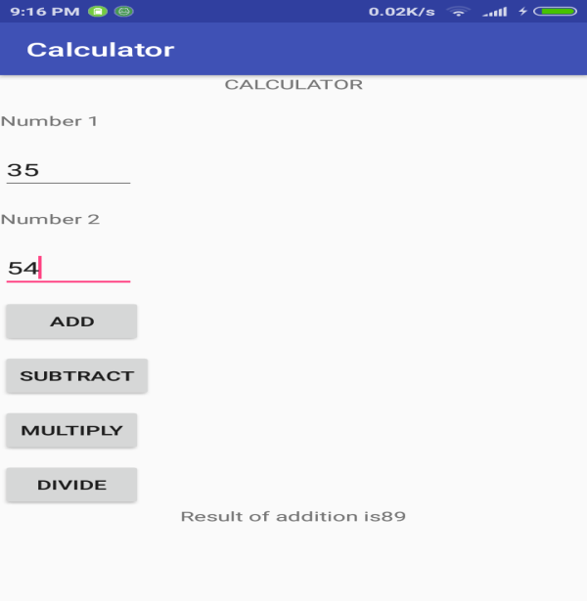

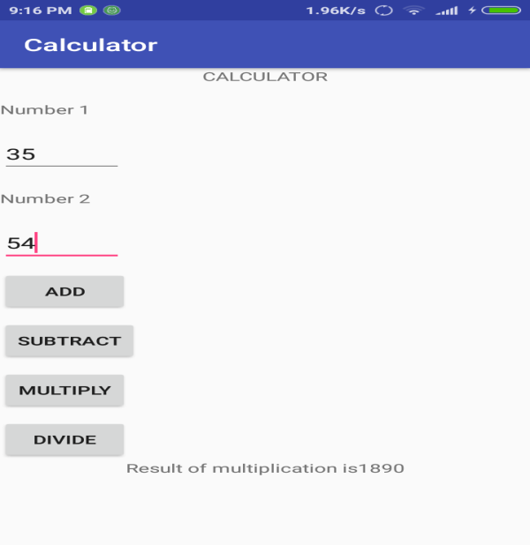

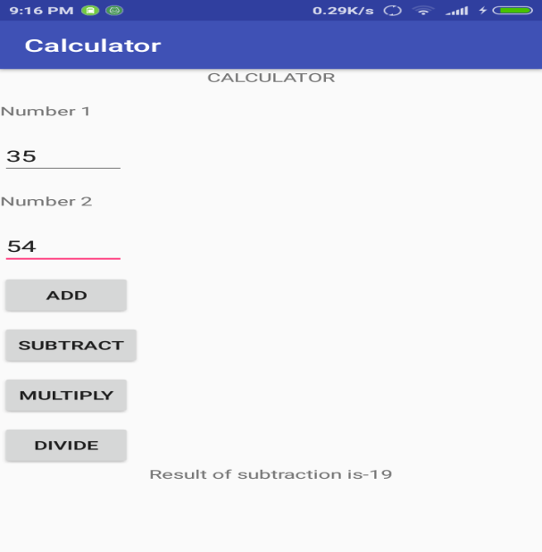

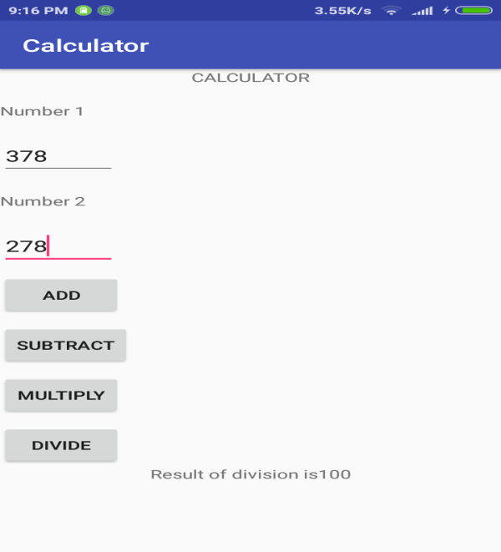

# Practical 6

Develop an android app which displays a form to get information such as username, password, email, phone, country, state and gender.

activitymain.xml:

<?xml version="1.0" encoding="utf-8"?>

<RelativeLayout xmlns:android="http://schemas.android.com/apk/res/android"

xmlns:app="http://schemas.android.com/apk/res-auto"

xmlns:tools="http://schemas.android.com/tools"

android:layout_width="match_parent"

android:layout_height="match_parent"

tools:context="com.example.login.MainActivity">

<TextView

android:id="@+id/txt_view1"

android:layout_width="wrap_content"

android:layout_height="wrap_content"

android:layout_alignParentTop="true"

android:layout_centerHorizontal="true"

android:layout_marginTop="10dp"

android:text="Login"/>

<TextView

android:layout_width="wrap_content"

android:layout_height="wrap_content"

android:id="@+id/txt_view2"

android:layout_alignParentLeft="true"

android:layout_marginTop="50dp"

android:layout_below="@+id/txt_view1"

android:layout_marginLeft="10dp"

android:text="Username:"/>

<EditText

android:layout_width="wrap_content"

android:layout_height="wrap_content"

android:id="@+id/userid"

android:layout_alignBottom="@+id/txt_view2"

android:layout_toRightOf="@+id/txt_view2"

android:layout_marginTop="30dp"

android:hint="supermode75"/>

<TextView

android:layout_width="wrap_content"

android:layout_height="wrap_content"

android:id="@+id/txt_view3"

android:layout_alignLeft="@+id/txt_view2"

android:layout_below="@+id/txt_view2"

android:text="Password:"

android:layout_marginTop="40dp"/>

<EditText

android:layout_width="wrap_content"

android:layout_height="wrap_content"

android:id="@+id/pass"

android:layout_alignBottom="@+id/txt_view3"

android:layout_alignLeft="@+id/userid"

android:layout_alignRight="@+id/userid"

android:hint="testPass"

android:inputType="textPassword"/>

<TextView

android:layout_width="wrap_content"

android:layout_height="wrap_content"

android:id="@+id/txt_mail"

android:text="Email :"

android:layout_marginTop="10dp"

android:layout_marginLeft="30dp"

android:layout_below="@+id/txt_view3"/>

<EditText

android:layout_width="wrap_content"

android:layout_height="wrap_content"

android:id="@+id/ed_mail"

android:layout_alignBottom="@+id/txt_mail"

android:layout_toRightOf="@+id/txt_mail"

android:layout_marginTop="30dp"

android:inputType="text"/>

<TextView

android:layout_width="wrap_content"

android:layout_height="wrap_content"

android:id="@+id/txt_phone"

android:text="Phone no:"

android:layout_marginTop="30dp"

android:layout_marginLeft="30dp"

android:layout_below="@+id/txt_mail"/>

<EditText

android:layout_width="wrap_content"

android:layout_height="wrap_content"

android:id="@+id/ed_phone"

android:layout_alignBottom="@+id/txt_phone"

android:layout_toRightOf="@+id/txt_phone"

android:layout_marginTop="30dp"

android:inputType="number"/>

<TextView

android:layout_width="wrap_content"

android:layout_height="wrap_content"

android:id="@+id/txt_country"

android:text="Country:"

android:layout_marginTop="30dp"

android:layout_marginLeft="30dp"

android:layout_below="@+id/txt_phone"/>

<EditText

android:layout_width="wrap_content"

android:layout_height="wrap_content"

android:id="@+id/ed_country"

android:layout_alignBottom="@+id/txt_country"

android:layout_toRightOf="@+id/txt_country"

android:layout_marginTop="30dp"

/>

<TextView

android:layout_width="wrap_content"

android:layout_height="wrap_content"

android:id="@+id/txt_gender"

android:text="Gender:"

android:layout_marginTop="30dp"

android:layout_marginLeft="30dp"

android:layout_below="@+id/txt_country"/>

<EditText

android:layout_width="wrap_content"

android:layout_height="wrap_content"

android:id="@+id/ed_gender"

android:inputType="text"

android:layout_alignBottom="@+id/txt_gender"

android:layout_toRightOf="@+id/txt_gender"

android:layout_marginTop="30dp"

/>

<TextView

android:layout_width="wrap_content"

android:layout_height="wrap_content"

android:id="@+id/txt_view4"

android:layout_below="@+id/txt_gender"

android:layout_marginLeft="20dp"

android:layout_marginTop="48dp"

android:text="Attempts Left :"

android:visibility="invisible"/>

<Button

android:layout_width="wrap_content"

android:layout_height="wrap_content"

android:id="@+id/btn"

android:layout_below="@+id/ed_gender"

android:layout_centerHorizontal="true"

android:layout_marginTop="94dp"

android:text="Login"/>

<TextView

android:layout_width="wrap_content"

android:layout_height="wrap_content"

android:id="@+id/loginLock"

android:visibility="invisible"

android:layout_marginTop="10dp"/>

<TextView

android:layout_width="wrap_content"

android:layout_height="wrap_content"

android:id="@+id/numremaining"

android:visibility="invisible"

android:layout_toRightOf="@+id/txt_view4"

android:layout_below="@+id/txt_gender"

android:layout_marginTop="90dp"/>

</RelativeLayout>

MainActivity.java:

package com.example.login;

import android.support.v7.app.AppCompatActivity;

import android.os.Bundle;

import android.graphics.Color;

import android.view.View;

import android.widget.Button;

import android.widget.EditText;

import android.widget.TextView;

import android.widget.Toast;

public class MainActivity extends AppCompatActivity {

private EditText username,password,email,phone,country,gender;

private Button login;

private TextView loginLock,attemptsLeft,numberLeft;

int numLeft=3;

@Override

protected void onCreate(Bundle savedInstanceState) {

super.onCreate(savedInstanceState);

setContentView(R.layout.activity_main);

setupVariables();

login.setOnClickListener(new View.OnClickListener() {

@Override

public void onClick(View v) {

if (username.getText().toString().equals("admin") && password.getText().toString().equals("admin")) {

Toast.makeText(getApplicationContext(), "Welcome Admin !", Toast.LENGTH_SHORT).show();

} else {

Toast.makeText(getApplicationContext(), "Not an authorized admin", Toast.LENGTH_SHORT).show();

numLeft--;

attemptsLeft.setVisibility(View.VISIBLE);

numberLeft.setVisibility(View.VISIBLE);

numberLeft.setText(Integer.toString(numLeft));

if (numLeft == 0) {

login.setEnabled(false);

loginLock.setVisibility(View.VISIBLE);

loginLock.setBackgroundColor(Color.RED);

loginLock.setText("LOGIN LOCKED!!"); }}

}

});

}

private void setupVariables(){

username=(EditText)findViewById(R.id.userid);

password=(EditText)findViewById(R.id.pass);

login=(Button)findViewById(R.id.btn);

loginLock=(TextView)findViewById(R.id.loginLock);

numberLeft=(TextView)findViewById(R.id.numremaining);

numberLeft.setText(Integer.toString(numLeft));

email=(EditText)findViewById(R.id.ed_mail);

phone=(EditText)findViewById(R.id.ed_phone);

gender=(EditText)findViewById(R.id.ed_gender);

attemptsLeft=(TextView)findViewById(R.id.txt_view4); }

}

# Output:

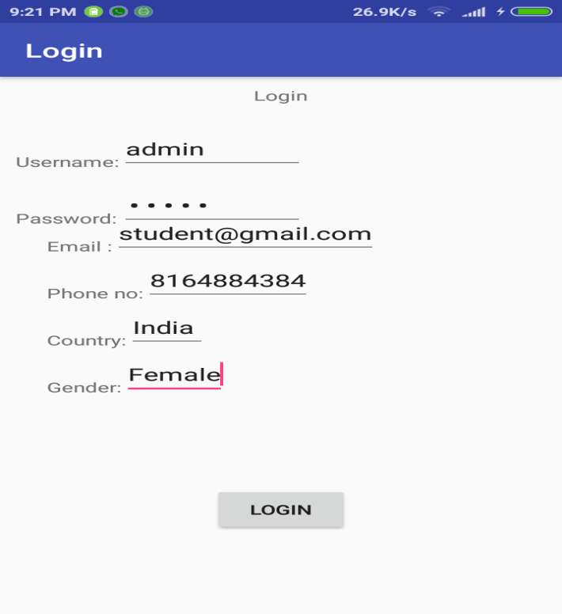

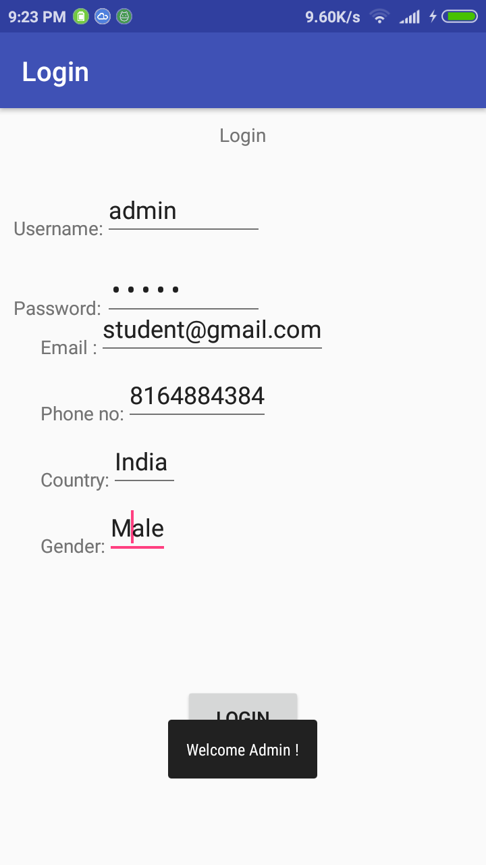

# Practical 7

Using Android, Create a login Activity. It asks “username” and “password” from user. If username and password are valid, it displays Welcome message using new activity.

activity_main.xml:

<?xml version="1.0" encoding="utf-8"?>

<RelativeLayout xmlns:android="http://schemas.android.com/apk/res/android"

xmlns:app="http://schemas.android.com/apk/res-auto"

xmlns:tools="http://schemas.android.com/tools"

android:layout_width="match_parent"

android:layout_height="match_parent"

android:background="@android:color/holo_blue_bright">

<TextView

android:id="@+id/txt_view1"

android:layout_width="wrap_content"

android:layout_height="wrap_content"

android:layout_alignParentTop="true"

android:layout_centerHorizontal="true"

android:layout_marginTop="10dp"

android:text="SignIn"

android:textAppearance="@style/TextAppearance.AppCompat.Display1" />

<TextView

android:layout_width="wrap_content"

android:layout_height="wrap_content"

android:id="@+id/txt_view2"

android:layout_marginLeft="10dp"

android:text="Username :"

android:layout_marginEnd="19dp"

android:layout_marginTop="26dp"

android:layout_below="@+id/txt_view1"

android:layout_toStartOf="@+id/userid" />

<EditText

android:id="@+id/userid"

android:layout_width="250dp"

android:layout_height="wrap_content"

android:hint="username"

android:layout_alignBaseline="@+id/txt_view2"

android:layout_alignBottom="@+id/txt_view2"

android:layout_alignParentEnd="true"

android:layout_marginEnd="13dp" />

<TextView

android:layout_width="wrap_content"

android:layout_height="wrap_content"

android:id="@+id/txt_view3"

android:text="Password :"

android:layout_alignBaseline="@+id/pass"

android:layout_alignBottom="@+id/pass"

android:layout_alignStart="@+id/txt_view2" />

<EditText

android:id="@+id/pass"

android:layout_width="250dp"

android:layout_height="wrap_content"

android:layout_marginTop="22dp"

android:hint="password"

android:inputType="textPassword"

android:layout_below="@+id/userid"

android:layout_alignStart="@+id/userid" />

<Button

android:layout_width="wrap_content"

android:layout_height="wrap_content"

android:id="@+id/btn"

android:layout_marginTop="67dp"

android:text="Login"

android:layout_below="@+id/pass"

android:layout_alignStart="@+id/pass" />

</RelativeLayout>

activity_user.xml:

<?xml version="1.0" encoding="utf-8"?>

<LinearLayout xmlns:android="http://schemas.android.com/apk/res/android"

android:orientation="vertical" android:layout_width="match_parent"

android:layout_height="match_parent"

xmlns:tools="http://schemas.android.com/tools"

tools:context=".user"

android:background="@android:color/holo_blue_bright">

<TextView

android:id="@+id/txt1"

android:layout_width="wrap_content"

android:layout_height="wrap_content"

android:layout_marginLeft="90dp"

android:layout_marginTop="250dp"

android:text="@string/screen_page"

android:textAppearance="@style/TextAppearance.AppCompat.Display1" />

</LinearLayout>

MainActivity.java:

package team4x.lyproject.practical10;

import android.content.Intent;

import android.graphics.Color;

import android.os.Bundle;

import android.support.v7.app.AppCompatActivity;

import android.view.View;

import android.widget.Button;

import android.widget.EditText;

import android.widget.TextView;

import android.widget.Toast;

public class MainActivity extends AppCompatActivity {

private EditText username,password;

private Button login;

@Override

protected void onCreate(Bundle savedInstanceState) {

super.onCreate(savedInstanceState);

setContentView(R.layout.activity_main);

username=(EditText)findViewById(R.id.userid);

password=(EditText)findViewById(R.id.pass);

login=(Button)findViewById(R.id.btn);

login.setOnClickListener(new View.OnClickListener() {

@Override

public void onClick(View v) {

if (username.getText().toString().equals("admin") && password.getText().toString().equals("123aa")) {

Toast.makeText(getApplicationContext(), "Welcome Admin !", Toast.LENGTH_SHORT).show();

Intent myIntent = new Intent(MainActivity.this,user.class);

startActivity(myIntent);

} else {

Toast.makeText(getApplicationContext(), "Not an authorized admin", Toast.LENGTH_SHORT).show();

}

}

});

}

}

user.java:

package team4x.lyproject.practical10;

import android.support.v7.app.AppCompatActivity;

import android.os.Bundle;

public class user extends AppCompatActivity {

@Override

protected void onCreate(Bundle savedInstanceState) {

super.onCreate(savedInstanceState);

setContentView(R.layout.activity_user);

}

}

# Output:

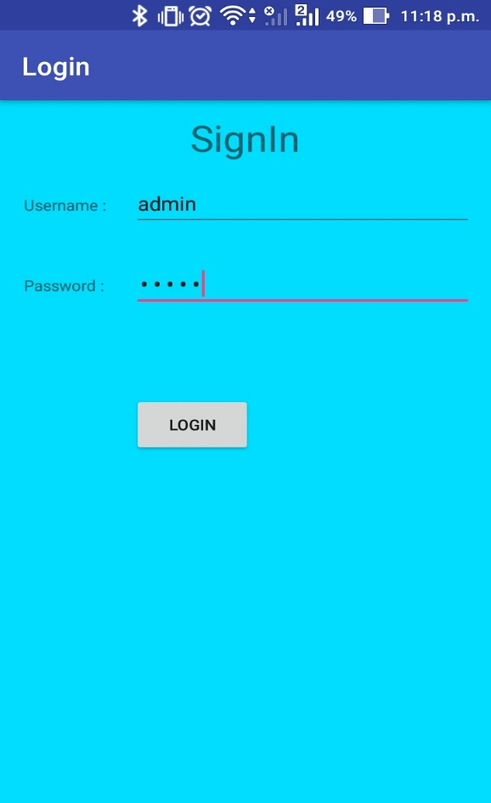 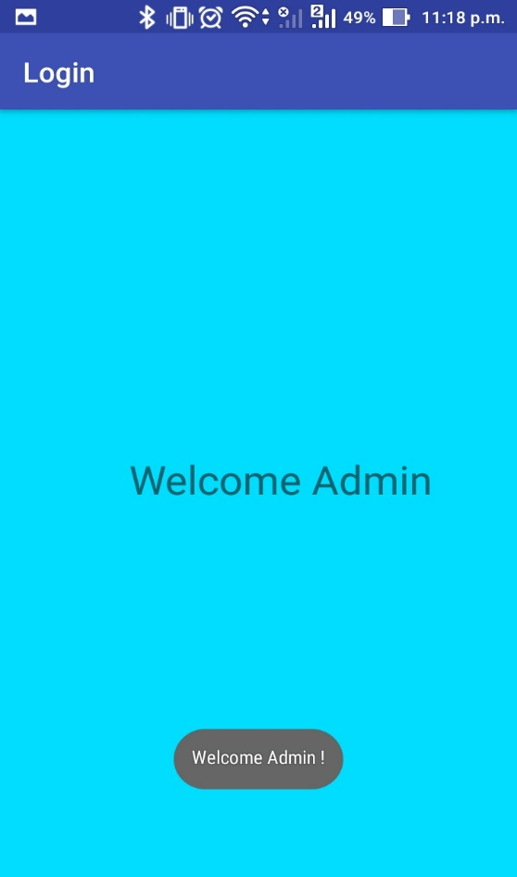

# Practical 8

Write a program to find hamming distance. For example, Hamming distance d (v1, v2) =3 if v1=011011, v2=110001.

#include<stdio.h>

#define BITS 8

int hamming(int ar1[],int ar2[]);

int input(int ar1[]);

int count_ham(int ar[]);

int n;

int main(){

int ar1[BITS],ar2[BITS];

printf("Enter the number of bits(max 8-bits):");

scanf("%d",&n);

printf("Enter a binary number(space between each bit and MAX 8-bit):");

input(ar1);

printf("Enter a binary number(space between each bit and MAX 8-bit):");

input(ar2);

hamming(ar1,ar2);

return 0;

}

int input(int ar1[]){

int i;

for(i=0;i<n;i++){

scanf("%d",&ar1[i]);

}

}

int count_ham(int ar[]){

int i,count=0;

for(i=0;i<n;i++){

if(ar[i]==1)

count++;

}

return count;

}

int hamming(int ar1[],int ar2[]){

int i,count;

int res[BITS];

for(i=0;i<n;i++){

if((ar1[i]==1 && ar2[i]==0)||(ar1[i]==0 && ar2[i]==1)){

res[i] = 1;

}

else{

res[i] = 0;

}

}

count = count_ham(res);

printf("Hamming distance will be: %d",count);

printf("\n");

}

# Output:

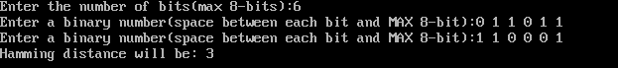

# Practical 9

Write a program that identifies the Bluetooth devices in the wireless range.

AndroidManifest.xml:

<?xml version="1.0" encoding="utf-8"?>

<manifest xmlns:android="http://schemas.android.com/apk/res/android"

package="team4x.lyproject.practical7">

<uses-permission android:name="android.permission.BLUETOOTH" />

<uses-permission android:name="android.permission.BLUETOOTH_ADMIN" />

<application

android:allowBackup="true"

android:icon="@mipmap/ic_launcher"

android:label="@string/app_name"

android:roundIcon="@mipmap/ic_launcher_round"

android:supportsRtl="true"

android:theme="@style/AppTheme">

<activity android:name=".MainActivity">

<intent-filter>

<action android:name="android.intent.action.MAIN" />

<category android:name="android.intent.category.LAUNCHER" />

</intent-filter>

</activity>

</application>

</manifest>

activity_main.xml:

<?xml version="1.0" encoding="utf-8"?>

<RelativeLayout

xmlns:android="http://schemas.android.com/apk/res/android"

xmlns:tools="http://schemas.android.com/tools"

android:layout_width="match_parent"

android:layout_height="match_parent"

android:background="@android:color/holo_blue_bright"

tools:context=".MainActivity"

android:transitionGroup="true">

<LinearLayout

android:layout_width="match_parent"

android:layout_height="match_parent"

android:orientation="vertical"

android:layout_centerVertical="true"

android:layout_marginTop="60dp"

android:layout_marginLeft="145dp">

<Button

android:layout_width="wrap_content"

android:layout_height="wrap_content"

android:text="Turn On"

android:id="@+id/button"

android:clickable="true"

android:onClick="on"

android:layout_below="@+id/textview"

android:layout_alignStart="@+id/button2"

android:layout_marginTop="14dp" />

<Button

android:id="@+id/button3"

android:layout_width="wrap_content"

android:layout_height="wrap_content"

android:layout_above="@+id/textView2"

android:layout_alignParentEnd="true"

android:layout_marginTop="14dp"

android:onClick="list"

android:text="Show " />

<Button

android:id="@+id/button4"

android:layout_width="wrap_content"

android:layout_height="wrap_content"

android:layout_alignParentLeft="true"

android:layout_alignParentStart="true"

android:layout_below="@+id/button"

android:onClick="off"

android:layout_marginTop="14dp"

android:text="turn off" />

</LinearLayout>

<TextView

android:id="@+id/textview"

android:layout_width="wrap_content"

android:layout_height="wrap_content"

android:layout_alignParentTop="true"

android:layout_centerHorizontal="true"

android:text="Practical 7"

android:textAppearance="@style/TextAppearance.AppCompat.Display1" />

<ListView

android:id="@+id/listView"

android:layout_width="wrap_content"

android:layout_height="wrap_content"

android:layout_alignParentBottom="true"

android:layout_alignParentEnd="true"

android:layout_marginStart="10dp"

android:layout_marginTop="50dp" />

</RelativeLayout>

Mainactivity.java

package team4x.lyproject.practical7;

import android.support.v7.app.AppCompatActivity;

import android.os.Bundle;

import android.bluetooth.BluetoothAdapter;

import android.bluetooth.BluetoothDevice;

import android.content.Intent;

import android.view.View;

import android.widget.ArrayAdapter;

import android.widget.Button;

import android.widget.ListView;

import android.widget.Toast;

import java.util.ArrayList;

import java.util.Set;

public class MainActivity extends AppCompatActivity {

Button b1,b2,b3,b4;

private BluetoothAdapter BA;

ListView lv;

@Override

protected void onCreate(Bundle savedInstanceState) {

super.onCreate(savedInstanceState);

setContentView(R.layout.activity_main);

b1 = (Button) findViewById(R.id.button);

b2=(Button)findViewById(R.id.button2);

b3=(Button)findViewById(R.id.button3);

b4=(Button)findViewById(R.id.button4);

BA = BluetoothAdapter.getDefaultAdapter();

lv = (ListView)findViewById(R.id.listView);

}

public void on(View v)

{

if (!BA.isEnabled())

{ Intent turnOn = new Intent(BluetoothAdapter.ACTION_REQUEST_ENABLE);

startActivityForResult(turnOn, 0);

Toast.makeText(getApplicationContext(), "Turned on",Toast.LENGTH_LONG).show();

}

else {

Toast.makeText(getApplicationContext(),"Already on",Toast.LENGTH_LONG).show();

}

}

public void off(View v)

{ BA.disable();

Toast.makeText(getApplicationContext(), "Turned off" ,Toast.LENGTH_LONG).show(); }

public void visible(View v){

Intent getVisible = new Intent(BluetoothAdapter.ACTION_REQUEST_DISCOVERABLE);

startActivityForResult(getVisible, 0);

}

public void list(View v){

Set<BluetoothDevice> pairedDevices = BA.getBondedDevices();

ArrayList<String> list = new ArrayList<>();

for(BluetoothDevice bt : pairedDevices)

list.add(bt.getName()){ Toast.makeText(getApplicationContext(), "Showing Paired Devices",Toast.LENGTH_SHORT).show();

final ArrayAdapter<String> adapter = new ArrayAdapter<>(this,android.R.layout.simple_list_item_1, list);

lv.setAdapter(adapter);

}

}

# Output:

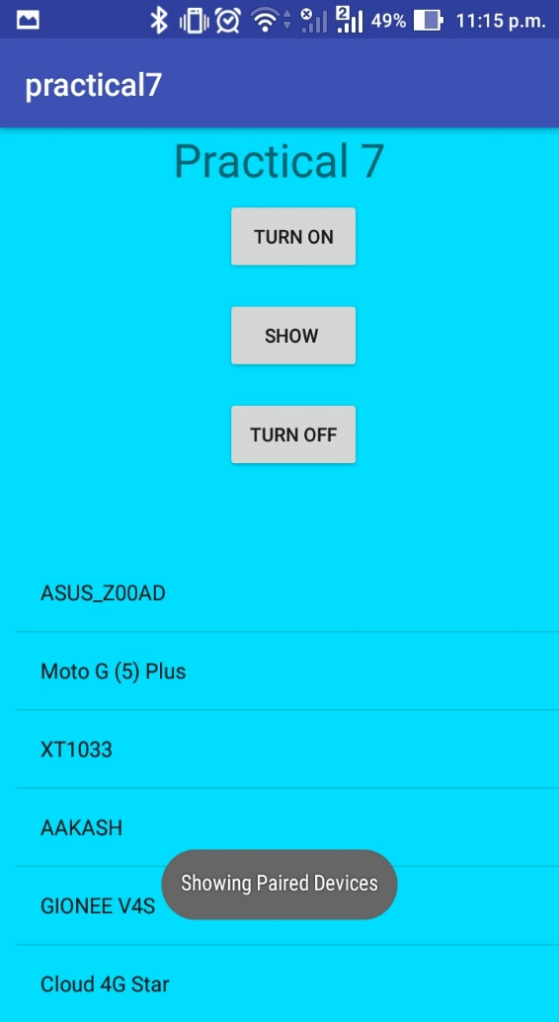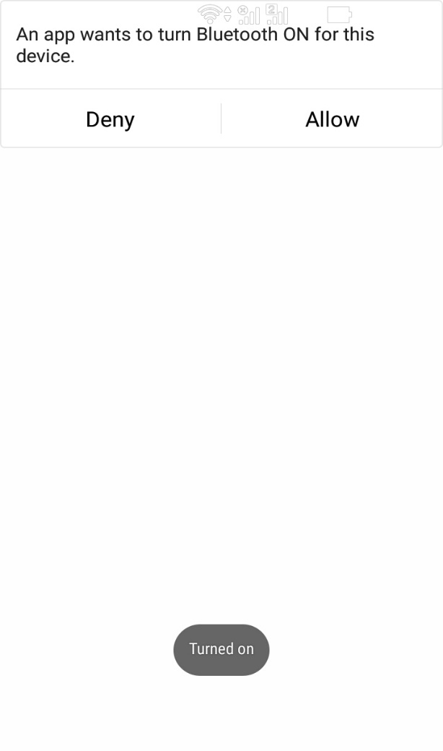

# Practical 10

Create an application which enable and disable the Wi-fi services

AndroidManifest.xml:

<?xml version="1.0" encoding="utf-8"?>

<manifest xmlns:android="http://schemas.android.com/apk/res/android"

package="team4x.lyproject.practical8">

<uses-permission android:name="android.permission.ACCESS_WIFI_STATE"/>

<uses-permission android:name="android.permission.CHANGE_WIFI_STATE" />

<application

android:allowBackup="true"

android:icon="@mipmap/ic_launcher"

android:label="@string/app_name"

android:roundIcon="@mipmap/ic_launcher_round"

android:supportsRtl="true"

android:theme="@style/AppTheme">

<activity android:name=".MainActivity">

<intent-filter>

<action android:name="android.intent.action.MAIN" />

<category android:name="android.intent.category.LAUNCHER" />

</intent-filter>

</activity>

</application>

</manifest>

activity_main.xml

<?xml version="1.0" encoding="utf-8"?>

<LinearLayout

xmlns:android="http://schemas.android.com/apk/res/android"

xmlns:tools="http://schemas.android.com/tools"

android:orientation="vertical"

android:layout_height="match_parent"

android:layout_width="match_parent"

android:layout_centerVertical="true"

android:background="@android:color/holo_blue_bright"

>

<Button

android:id="@+id/btn1"

android:layout_width="wrap_content"

android:layout_height="wrap_content"

android:layout_marginBottom="20dp"

android:layout_marginLeft="140dp"

android:layout_marginTop="220dp"

android:text="Turn On" />

<Button

android:id="@+id/btn2"

android:layout_width="wrap_content"

android:layout_height="wrap_content"

android:layout_marginLeft="140dp"

android:text="Turn Off" />

</LinearLayout>

MainActivity.java:

package team4x.lyproject.practical8;

import android.content.Context;

import android.net.wifi.WifiManager;

import android.support.v7.app.AppCompatActivity;

import android.os.Bundle;

import android.view.View;

import android.widget.Button;

import android.widget.Toast;

public class MainActivity extends AppCompatActivity {

@Override

protected void onCreate(Bundle savedInstanceState) {

super.onCreate(savedInstanceState);

setContentView(R.layout.activity_main);

Button b1 = (Button)findViewById(R.id.btn1);

Button b2 = (Button)findViewById(R.id.btn2);

final WifiManager wm = (WifiManager)getSystemService(Context.WIFI_SERVICE);

b1.setOnClickListener(new View.OnClickListener() {

@Override

public void onClick(View v) {

if(!wm.isWifiEnabled()){

wm.setWifiEnabled(true);

Toast.makeText(MainActivity.this,"Wifi Enabled",Toast.LENGTH_LONG).show();;

}

}

});

b2.setOnClickListener(new View.OnClickListener() {

@Override

public void onClick(View v) {

if(wm.isWifiEnabled()){

wm.setWifiEnabled(false);

Toast.makeText(MainActivity.this,"Wifi Disabled",Toast.LENGTH_LONG).show();

}

}

});

}

}

# Output:

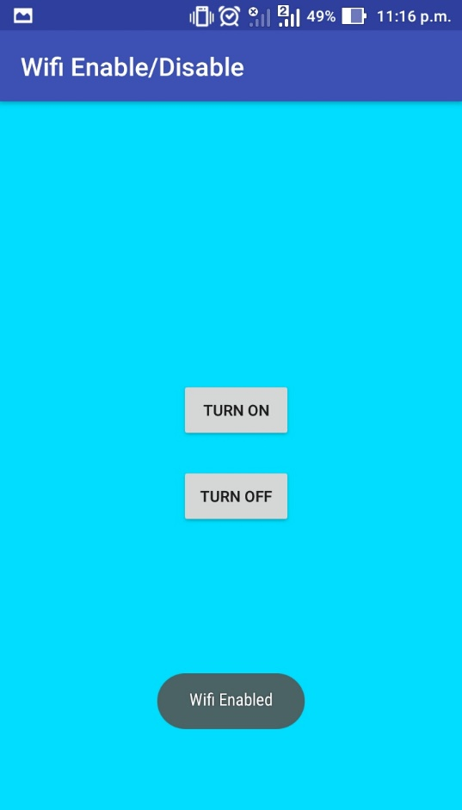 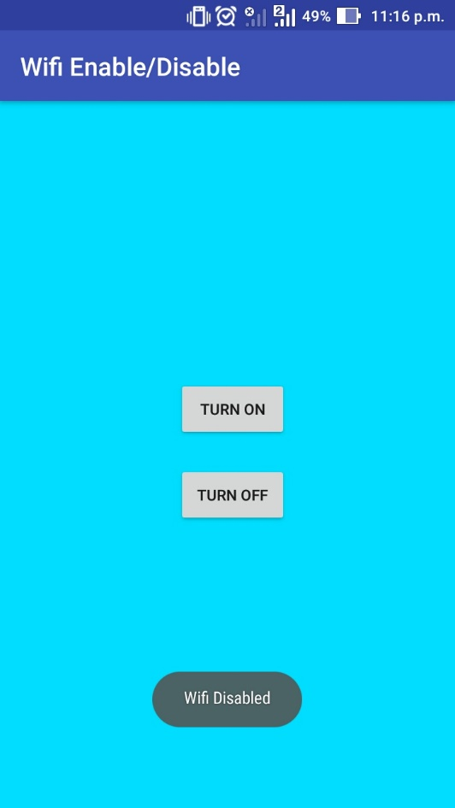

# Practical 11

Create an android application that will create Database to store username and password.

activity_main.xml

<?xml version="1.0" encoding="utf-8"?>

<RelativeLayout xmlns:android="http://schemas.android.com/apk/res/android"

xmlns:app="http://schemas.android.com/apk/res-auto"

xmlns:tools="http://schemas.android.com/tools"

android:layout_width="match_parent"

android:layout_height="match_parent"

tools:context=".LoginActivity">

<EditText

android:id="@+id/uname"

android:layout_width="292dp"

android:layout_height="wrap_content"

android:layout_alignParentTop="true"

android:layout_alignParentEnd="true"

android:layout_marginTop="73dp"

android:layout_marginEnd="47dp"

android:ems="10"

android:hint="User Name"

android:inputType="textPersonName" />

<EditText

android:id="@+id/password"

android:layout_width="286dp"

android:layout_height="wrap_content"

android:layout_below="@+id/uname"

android:layout_alignStart="@+id/uname"

android:layout_marginStart="2dp"

android:layout_marginTop="54dp"

android:ems="10"

android:hint="Password"

android:inputType="textPassword" />

<Button

android:id="@+id/add"

android:layout_width="109dp"

android:layout_height="wrap_content"

android:layout_below="@+id/password"

android:layout_alignParentStart="true"

android:layout_marginStart="60dp"

android:layout_marginTop="90dp"

android:text="ADD" />

<Button

android:id="@+id/view"

android:layout_width="108dp"

android:layout_height="wrap_content"

android:layout_alignTop="@+id/add"

android:layout_marginStart="54dp"

android:layout_toEndOf="@+id/add"

android:text="View" />

</RelativeLayout>

Mainactivity.java

package com.example.karan.practical11;

import android.database.Cursor;

import android.support.v7.app.AlertDialog;

import android.support.v7.app.AppCompatActivity;

import android.os.Bundle;

import android.view.View;

import android.widget.Button;

import android.widget.EditText;

import android.widget.Toast;

public class LoginActivity extends AppCompatActivity {

DataBaseHelper1 mydb;

EditText uname,password;

Button Add, View;

@Override

protected void onCreate(Bundle savedInstanceState) {

super.onCreate(savedInstanceState);

setContentView(R.layout.activity_login);

mydb = new DataBaseHelper1(this);

uname = (EditText) findViewById(R.id.uname);

password = (EditText) findViewById(R.id.password);

Add = (Button) findViewById(R.id.add);

View = (Button) findViewById(R.id.view);

Add.setOnClickListener(new android.view.View.OnClickListener() {

@Override

public void onClick(View v) {

boolean check = mydb.insertData(uname.getText().toString(), password.getText().toString());

if (check == true)

Toast.makeText(LoginActivity.this, "Data Inserted", Toast.LENGTH_LONG).show();

else

Toast.makeText(LoginActivity.this, "Insertion Error", Toast.LENGTH_LONG).show();

}

});

View.setOnClickListener(new View.OnClickListener() {

@Override

public void onClick(View v) {

Cursor res = mydb.getAllData();

if (res.getCount() == 0) {

showMessage("Error", "Nothing Found");

return;

} else {

StringBuffer buffer = new StringBuffer();

while (res.moveToNext()) {

buffer.append("User : " + res.getString(1) + "\n");

buffer.append("Password : " + res.getString(2) + "\n\n");

}

showMessage("Data", buffer.toString());

}

}

});

}

//Outside Oncreate

public void showMessage(String title, String Message)

{

AlertDialog.Builder builder = new AlertDialog.Builder(this);

builder.setCancelable(true);

builder.setTitle(title);

builder.setMessage(Message);

builder.show();

}

}

DatabaseHelper1.java

package com.example.karan.practical11;

import android.content.ContentValues;

import android.content.Context;

import android.database.Cursor;

import android.database.sqlite.SQLiteDatabase;

import android.database.sqlite.SQLiteOpenHelper;

public class DataBaseHelper1 extends SQLiteOpenHelper {

public static final String DATABASE_NAME = "User_Database";

public static final String TABLE_NAME = "User_List";

public static final String COL_1 = "UserName";

public static final String COL_2 = "Password";

public DataBaseHelper1(Context context)

{

super(context, DATABASE_NAME, null, 1);

SQLiteDatabase db = this.getWritableDatabase();

}

@Override

public void onCreate(SQLiteDatabase db)

{

db.execSQL("create table " + TABLE_NAME + "(ID INTEGER PRIMARY KEY AUTOINCREMENT,USERNAME TEXT, PASSWORD TEXT)");

}

@Override

public void onUpgrade(SQLiteDatabase db, int oldVersion, int newVersion)

{ }

public boolean insertData(String uname, String password)

{

SQLiteDatabase db = this.getWritableDatabase();

ContentValues contentValues = new ContentValues();

contentValues.put(COL_1, uname);

contentValues.put(COL_2, password);

long result = db.insert(TABLE_NAME, null, contentValues);

if (result == -1)

{

return false;

} else

{

return true;

}

}

//for Viewing the Data

public Cursor getAllData()

{

SQLiteDatabase db = this.getWritableDatabase();

Cursor res = db.rawQuery("select * from " + TABLE_NAME, null);

return res;

}

}

# Output:

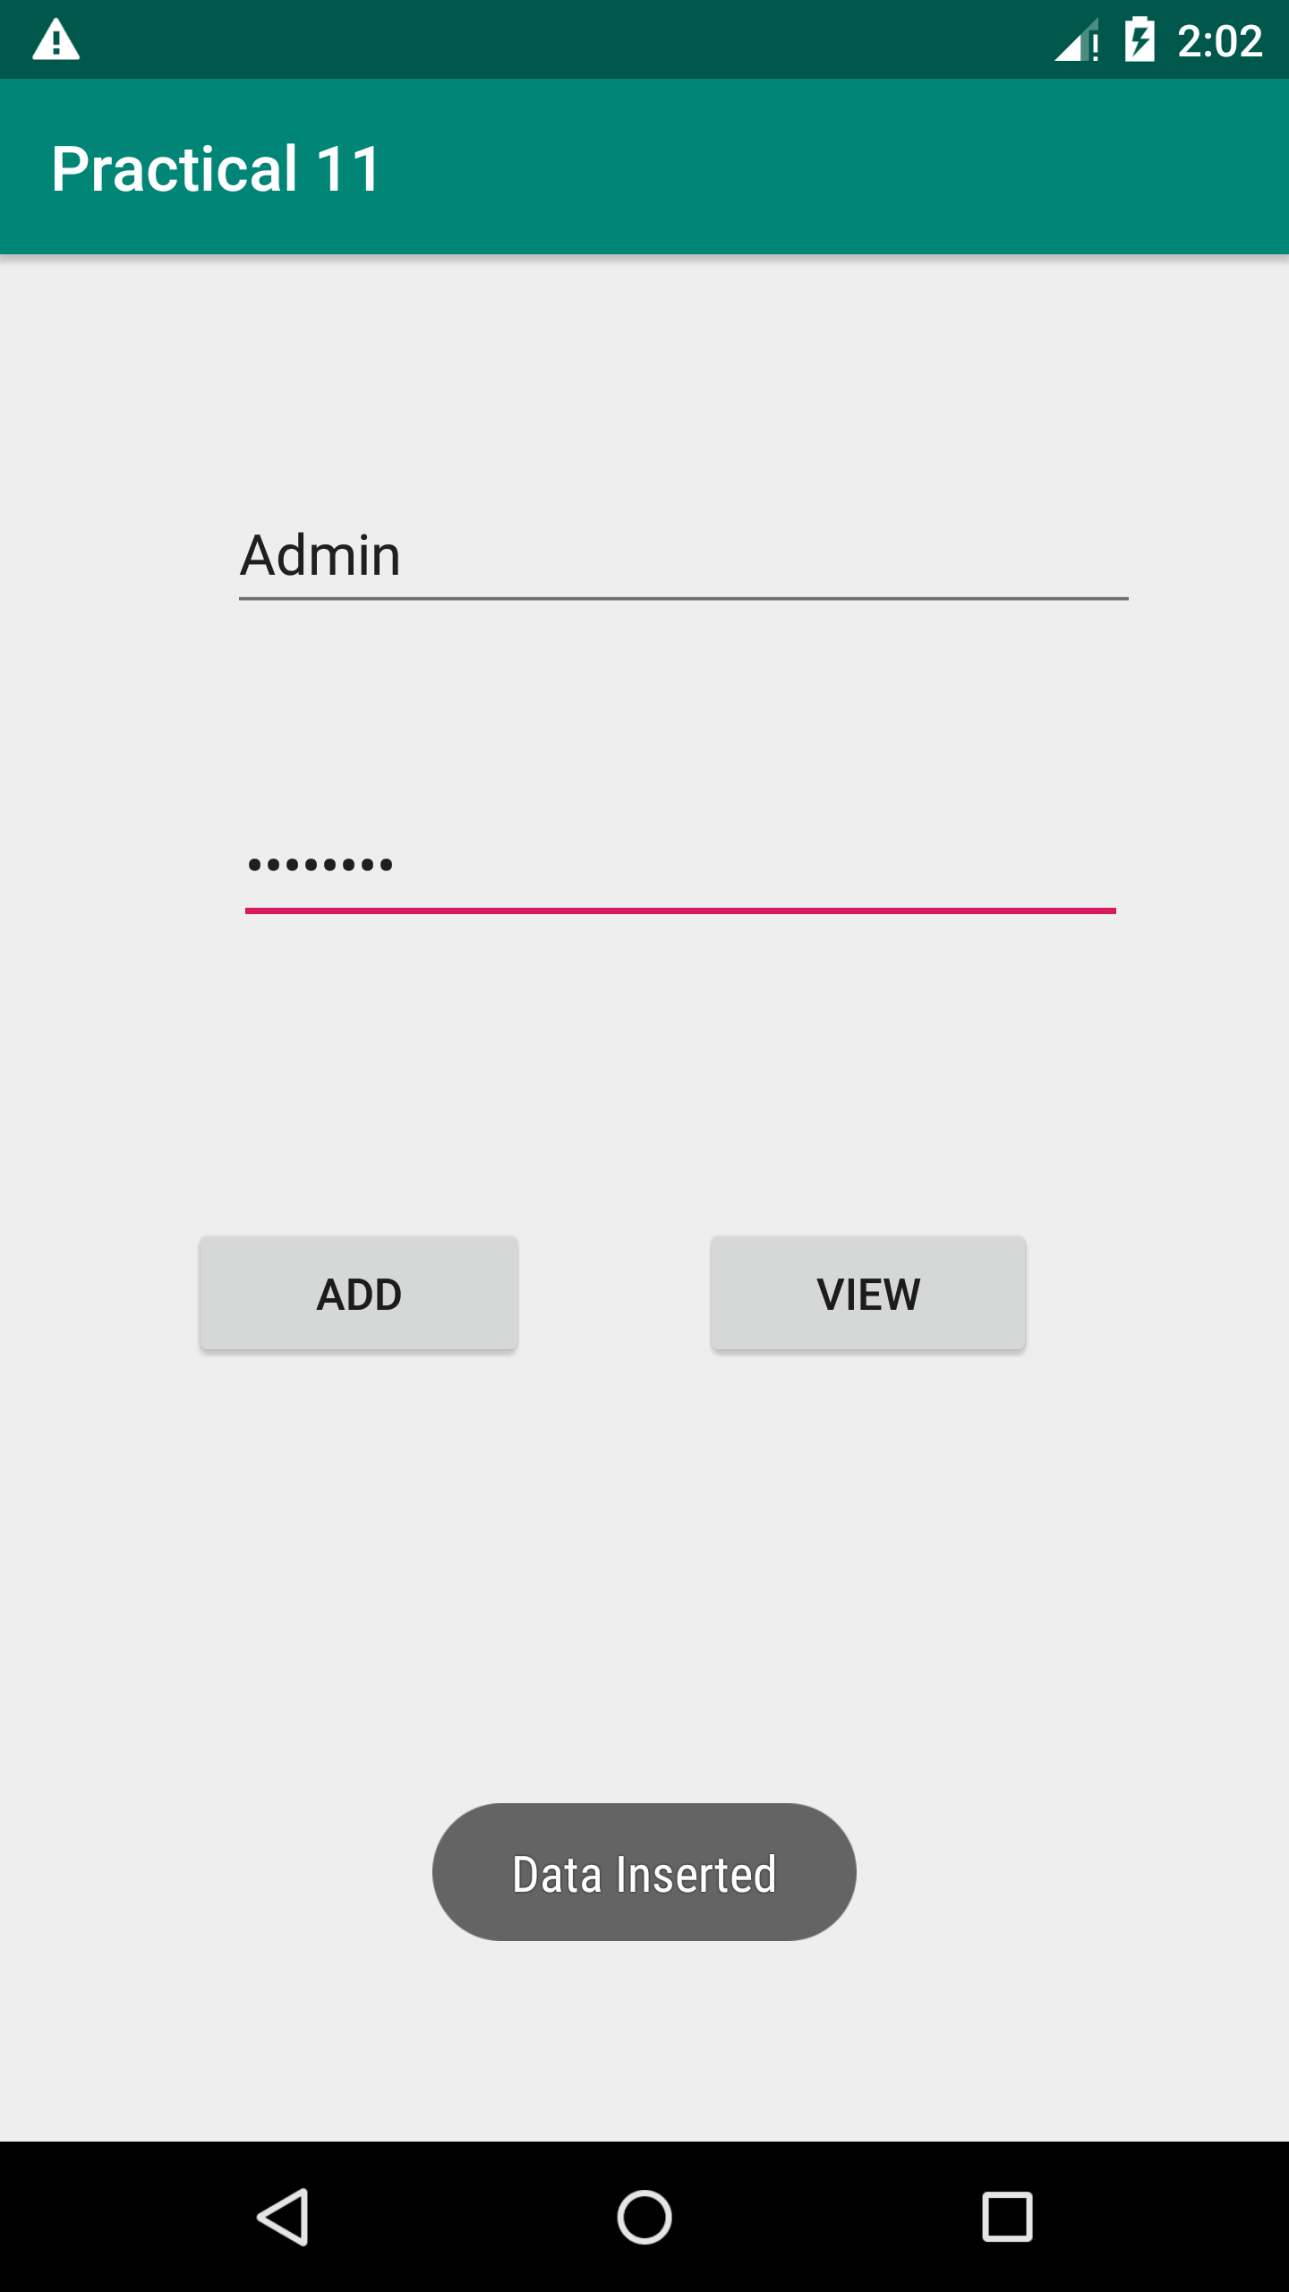 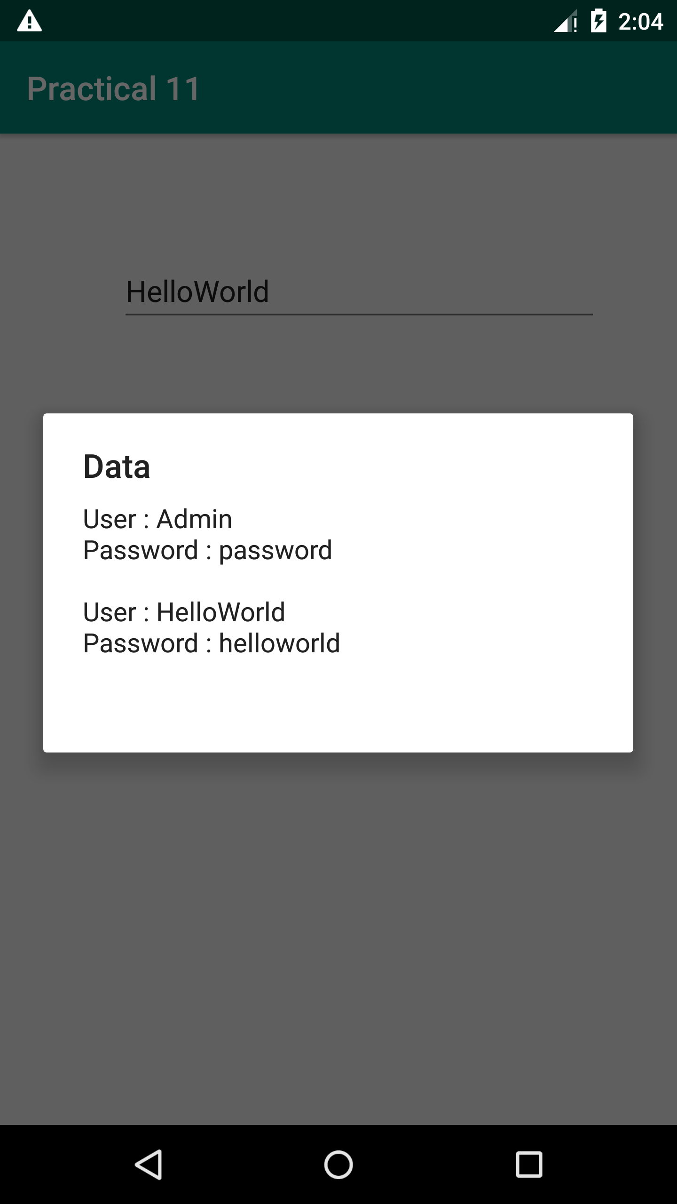

# Practical 12

Create an android application to insert, update and Delete records from database.

activity_main.xml:

<?xml version="1.0" encoding="utf-8"?>

<RelativeLayout xmlns:android="http://schemas.android.com/apk/res/android"

xmlns:app="http://schemas.android.com/apk/res-auto"

xmlns: tools="http://schemas.android.com/tools"

android:layout_width="match_parent"

android:layout_height="match_parent"

tools:context="com.example.bhavesh.shopping_databasepractical.MainActivity">

<TextView

android:id="@+id/textView4"

android:layout_width="wrap_content"

android:layout_height="wrap_content"

android:textSize="15sp"

android:layout_marginTop="120dp"

android:text="Name"

android:layout_alignParentTop="true"

android:layout_alignStart="@+id/textView5" />

<EditText

android:id="@+id/editText4"

android:layout_width="wrap_content"

android:layout_height="wrap_content"

android:ems="10"

android:inputType="textPersonName"

android:hint="Name"

android:layout_marginEnd="31dp"

android:layout_alignBaseline="@+id/textView4"

android:layout_alignBottom="@+id/textView4"

android:layout_alignParentEnd="true" />

<TextView

android:id="@+id/textView5"

android:textSize="15sp"

android:layout_width="wrap_content"

android:layout_height="wrap_content"

android:text="Item Name"

android:layout_marginStart="29dp" android:layout_alignBaseline="@+id/editText5" android:layout_alignBottom="@+id/editText5" android:layout_alignParentStart="true" />

<EditText

android:id="@+id/editText5"

android:layout_width="wrap_content"

android:layout_height="wrap_content"

android:layout_marginTop="28dp"

android: ems="10"

android:inputType="textPersonName"

android:hint="Item"

android:layout_below="@+id/editText4"

android:layout_alignStart="@+id/editText4" />

<TextView

android:id="@+id/textView6"

android:textSize="15sp"

android:layout_width="wrap_content"

android:layout_height="wrap_content"

android:text="Price"

android:layout_marginTop="37dp"

android:layout_below="@+id/editText5"

android:layout_alignStart="@+id/textView5" />

<EditText

android:id="@+id/editText6"

android:layout_width="wrap_content"

android:layout_height="wrap_content"

android:ems="10"

android:inputType="textPersonName"

android:hint="Price"

android:layout_alignBaseline="@+id/textView6"

android:layout_alignBottom="@+id/textView6"

android:layout_alignStart="@+id/editText5" />

<Button

android:id="@+id/add"

android:layout_width="wrap_content"

android:layout_height="wrap_content"

android:layout_marginTop="38dp"

android:text="ADD"

android:layout_below="@+id/editText6"

android:layout_toStartOf="@+id/editText6" />

<Button

android:id="@+id/view"

android:layout_width="wrap_content"

android:layout_height="wrap_content"

android:layout_alignTop="@+id/add"

android:layout_marginStart="54dp"

android:layout_toEndOf="@+id/add"

android:text="View" />

<Button

android:id="@+id/update"

android:layout_width="wrap_content"

android:layout_height="wrap_content"

android:layout_alignStart="@+id/add"

android:layout_below="@+id/add"

android:layout_marginTop="38dp"

android:text="Update" />

<Button

android:id="@+id/delete"

android:layout_width="wrap_content"

android:layout_height="wrap_content"

android:layout_alignBaseline="@+id/update"

android:layout_alignBottom="@+id/update"

android:layout_alignStart="@+id/view"

android:text="Delete" />

<EditText

android:id="@+id/editText"

android:layout_width="wrap_content"

android:layout_height="wrap_content"

android:ems="10"

android:inputType="textPersonName"

android:hint="Id"

android:layout_above="@+id/editText4"

android:layout_alignStart="@+id/editText4"

android:layout_marginBottom="17dp" />

<TextView

android:id="@+id/textView2"

android:layout_width="wrap_content"

android:layout_height="wrap_content"

android:text="Id"

android:layout_alignBaseline="@+id/editText" android:layout_alignBottom="@+id/editText" android:layout_alignStart="@+id/textView4" />

</RelativeLayout>

Mainactivity.java

package com.example.bhavesh.shopping_databasepractical;

import android.database.Cursor;

import android.support.v7.app.AlertDialog;

import android.support.v7.app.AppCompatActivity; import android.os.Bundle; import android.view.View;

import android.widget.Button;

import android.widget.EditText;

import android.widget.Toast;

public class MainActivity extends AppCompatActivity {

DataBaseHelper mydb;

EditText Name,ItemName,Price,Id;

Button Add,View,Update,Delete;

@Override

protected void onCreate(Bundle savedInstanceState) { super.onCreate(savedInstanceState); setContentView(R.layout.activity_main);

mydb = new DataBaseHelper(this);

Name = (EditText) findViewById(R.id.editText4); ItemName = (EditText) findViewById(R.id.editText5); Price = (EditText) findViewById(R.id.editText6); Id=(EditText)findViewById(R.id.editText); Add = (Button) findViewById(R.id.add); View = (Button) findViewById(R.id.view); Update=(Button)findViewById(R.id.update); Delete=(Button)findViewById(R.id.delete);

Add.setOnClickListener(new android.view.View.OnClickListener() { @Override

public void onClick(View v) {

boolean check = mydb.insertData(Name.getText().toString(), ItemName.getText().toString(), Price.getText().toString());

if (check == true)

Toast.makeText(MainActivity.this, "Data Inserted", Toast.LENGTH_LONG).show();

else

Toast.makeText(MainActivity.this, "Insertion Error", Toast.LENGTH_LONG).show();

}

});

View.setOnClickListener(new View.OnClickListener() { @Override

public void onClick(View v) {

Cursor res = mydb.getAllData();

if (res.getCount() == 0) {

showMessage("Error", "Nothing Found");

return;

}

else

{

StringBuffer buffer = new StringBuffer();

while (res.moveToNext())

{

buffer.append("Name : " + res.getString(1) + "\n");

buffer.append("I_Name: " + res.getString(2) + "\n");

buffer.append("Price : " + res.getString(3) + "\n\n");

}

showMessage("Data", buffer.toString());

}

}

});

Update.setOnClickListener(new View.OnClickListener()

{

@Override

public void onClick(View v)

{

boolean

isUpdated=mydb.updateData(Id.getText().toString(),Name.getText().toString(),ItemName.ge

tText().toString()

,Price.getText().toString());

if(isUpdated == true)

Toast.makeText(MainActivity.this, "Data Updated", Toast.LENGTH_LONG).show();

else

Toast.makeText(MainActivity.this, "Data Updation Error", Toast.LENGTH_LONG).show();

}

});

Delete.setOnClickListener(new View.OnClickListener()

{

@Override

public void onClick(View v)

{

Integer deletedRows=mydb.deleteData(Id.getText().toString()); if(deletedRows > 0)

Toast.makeText(MainActivity.this, "Data Deleted", Toast.LENGTH_LONG).show(); else

Toast.makeText(MainActivity.this, "Data not Deleted", Toast.LENGTH_LONG).show();

}

});

}

//Outside Oncreate

public void showMessage(String title,String Message)

{

AlertDialog.Builder builder=new AlertDialog.Builder(this);

builder.setCancelable(true);

builder.setTitle(title);

builder.setMessage(Message);

builder.show();

}

}

DatabaseHalper.java

package com.example.bhavesh.shopping_databasepractical;

import android.content.ContentValues;

import android.content.Context;

import android.database.Cursor;

import android.database.sqlite.SQLiteDatabase; import android.database.sqlite.SQLiteOpenHelper;

public class DataBaseHelper extends SQLiteOpenHelper {

public static final String DATABASE_NAME="Shopping_Database";

public static final String TABLE_NAME="Shopping_List"; public static final String COL_1="ID";

public static final String COL_2="NAME"; public static final String COL_3="ITEM_NAME"; public static final String COL_4="PRICE";

public DataBaseHelper(Context context)

{

super(context, DATABASE_NAME, null, 1); SQLiteDatabase db=this.getWritableDatabase();

}

@Override

public void onCreate(SQLiteDatabase db)

{

db.execSQL("create table "+TABLE_NAME+"(ID INTEGER PRIMARY KEY AUTOINCREMENT,NAME INTEGER,ITEM_NAME TEXT,PRICE INTEGER)");

}

@Override

public void onUpgrade(SQLiteDatabase db, int oldVersion, int newVersion)

{

}

public boolean insertData(String name,String ItemName,String Price)

{

SQLiteDatabase db=this.getWritableDatabase(); ContentValues contentValues=new ContentValues(); contentValues.put(COL_2,name); contentValues.put(COL_3,ItemName); contentValues.put(COL_4,Price);

long result= db.insert(TABLE_NAME,null,contentValues);

if(result==-1)

{

return false;

}

else

{

return true;

}

}

//for Viewing the Data

public Cursor getAllData()

{

SQLiteDatabase db=this.getWritableDatabase();

Cursor res=db.rawQuery("select * from "+TABLE_NAME,null); return res;

}

//for Update

public boolean updateData(String id,String name,String itemname,String price)

{

SQLiteDatabase db=this.getWritableDatabase();

ContentValues contentValues=new ContentValues();

contentValues.put(COL_1,id);

contentValues.put(COL_2,name);

contentValues.put(COL_3,itemname);

contentValues.put(COL_4,price);

db.update(TABLE_NAME,contentValues," ID= ?",new String[]{id});

return true;

}

public Integer deleteData(String id)

{

SQLiteDatabase db=this.getWritableDatabase();

return db.delete(TABLE_NAME,"ID=?",new String[]{id});

}

}

# Output:

